**MongoDB - how to install MongoDB**

**Step 1 — Download the MongoDB MSI Installer Package**

Head over [here](https://www.mongodb.com/download-center/community) and download the current version of MongoDB. Make sure you **select MSI**as the package you want to download.



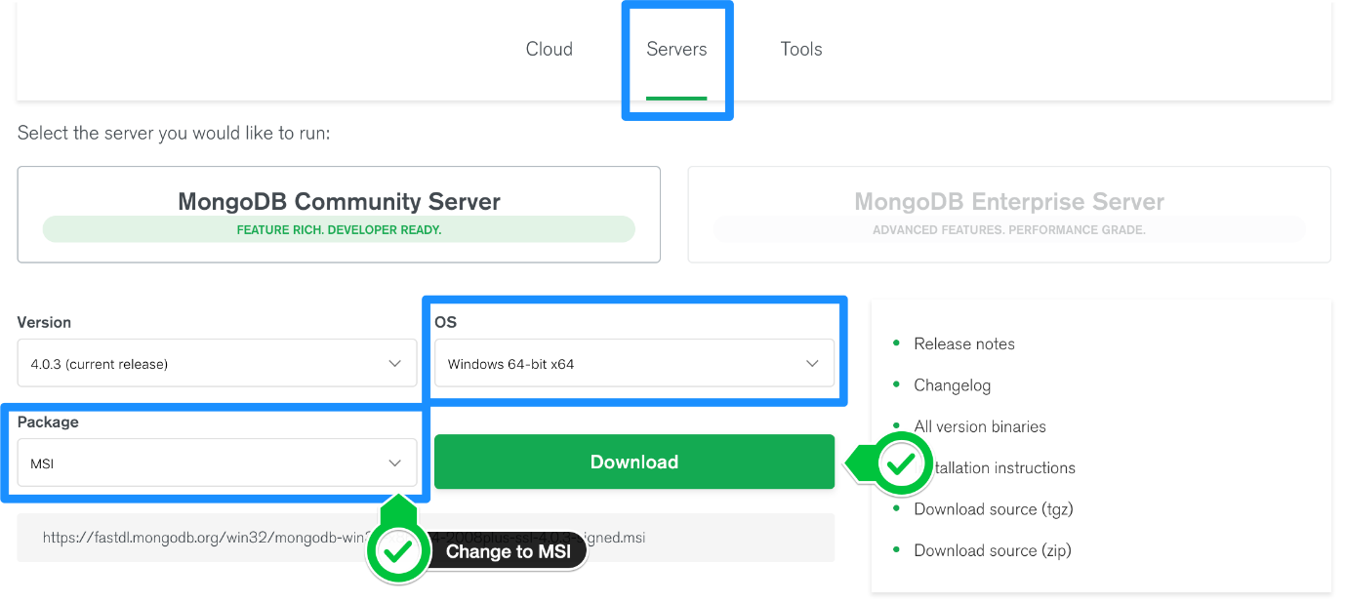

**Step 2 — Install MongoDB with the Installation Wizard**

A. Make sure you are logged in as a user with Admin privileges. Then navigate to your downloads folder and double click on the .msi package you just downloaded. This will launch the installation wizard.



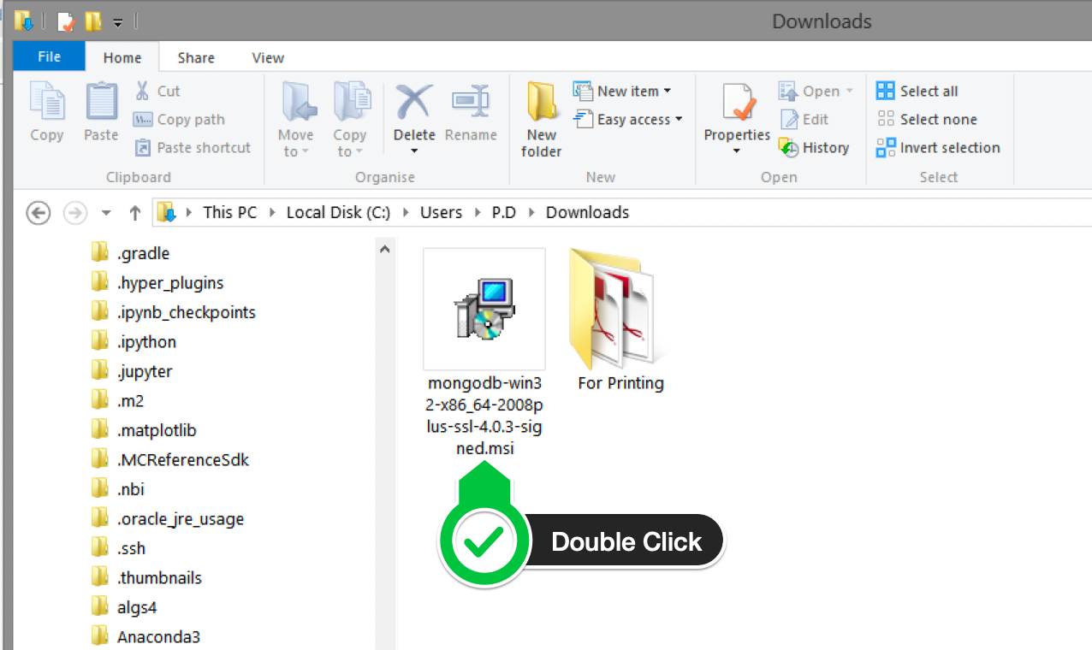

B. Click Next to start installation.



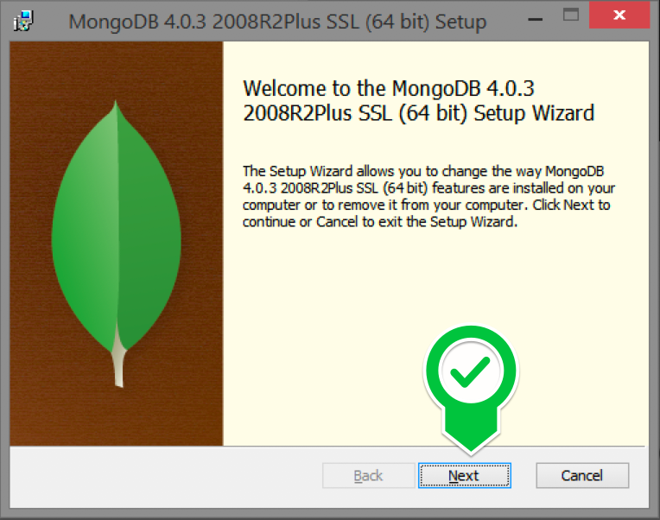

C. Accept the licence agreement then click Next.



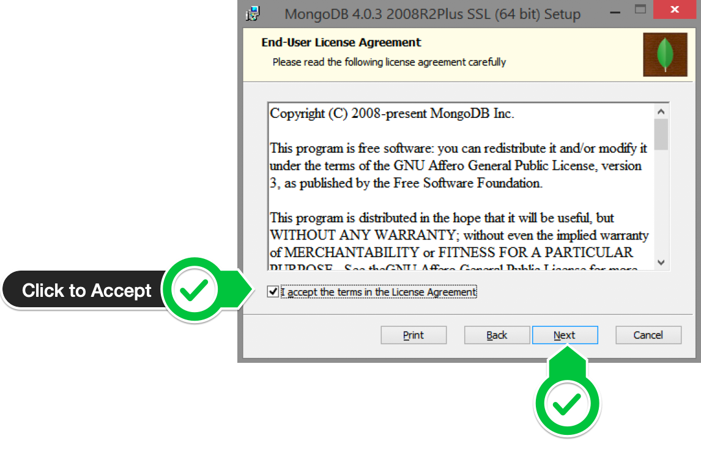

D. Select the Complete setup.



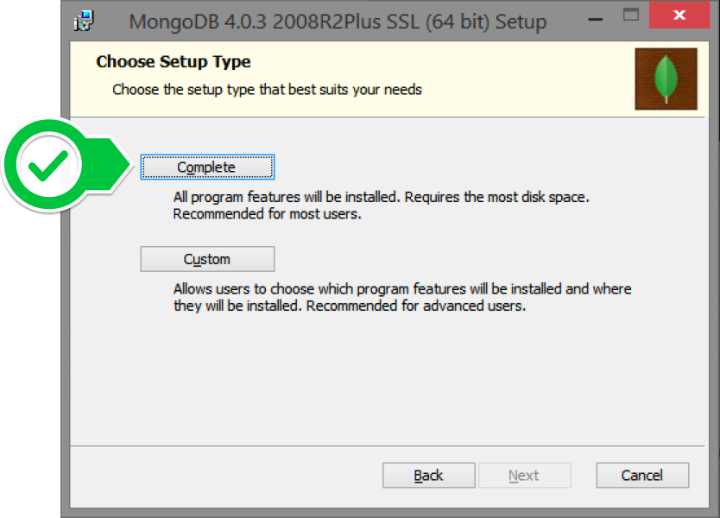

E. Select “Run service as Network Service user” and make a note of the data directory, we’ll need this later.



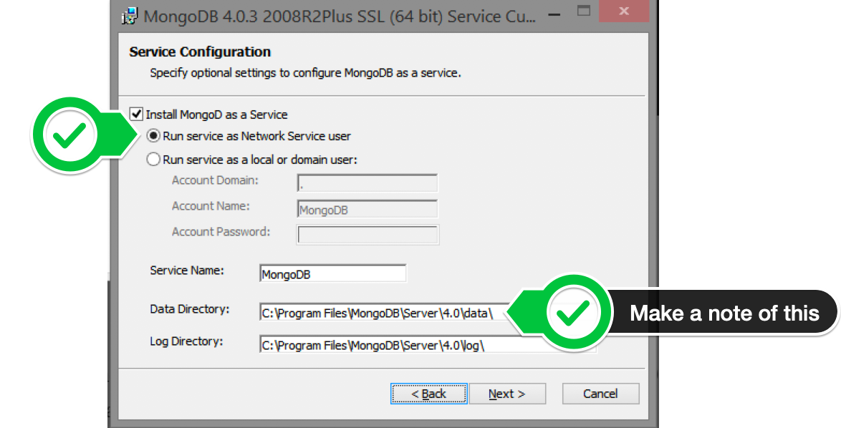

F. We won’t need Mongo Compass, so deselect it and click Next.



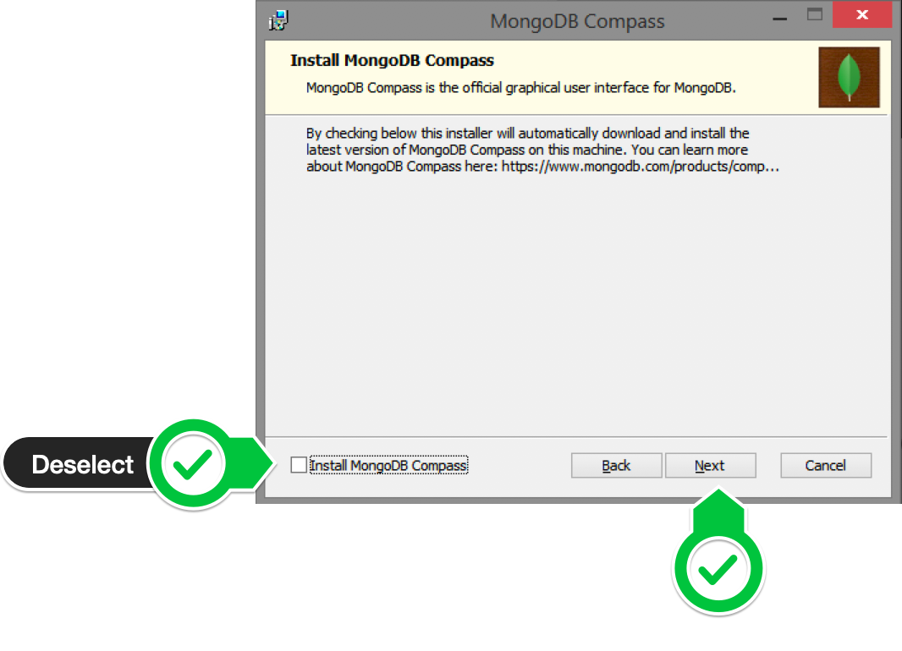

G. Click Install to begin installation.



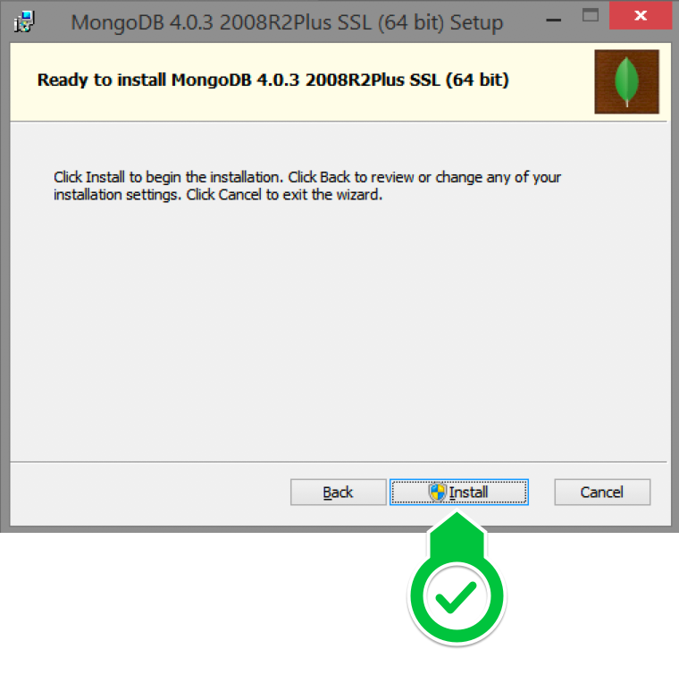

F. Hit Finish to complete installation.



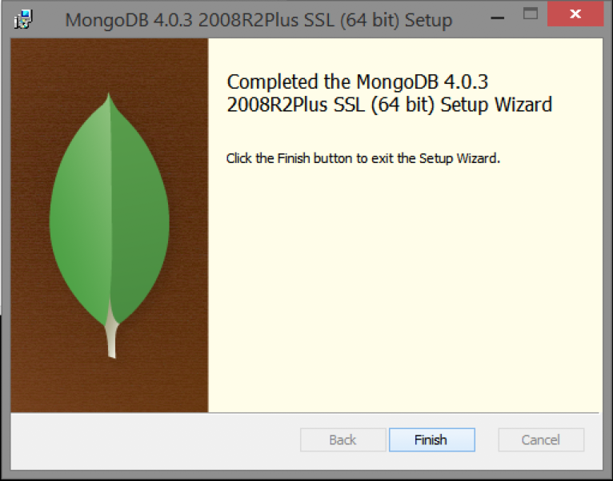

**Step 3— Create the Data Folders to Store our Databases**

A. Navigate to the **C Drive** on your computer using Explorer and create a new folder called **data** here.



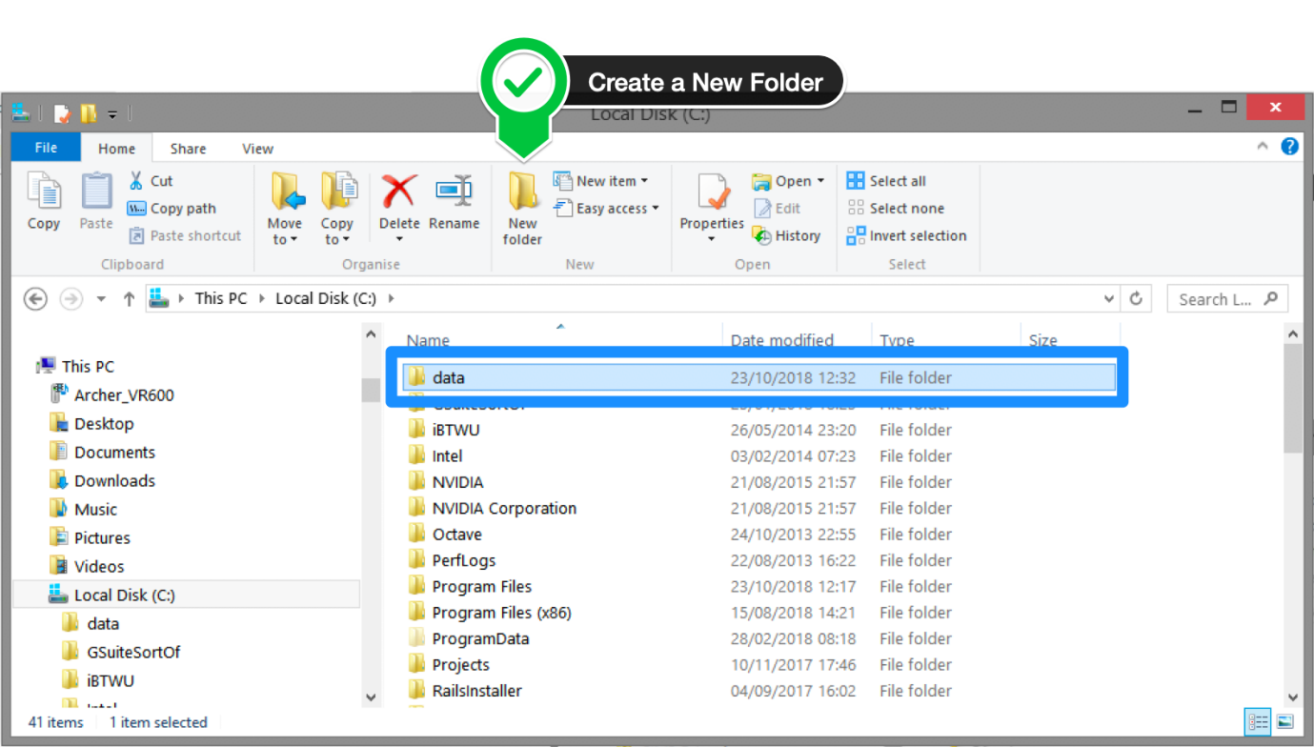

B. Inside the **data** folder you just created, create another folder called **db**.



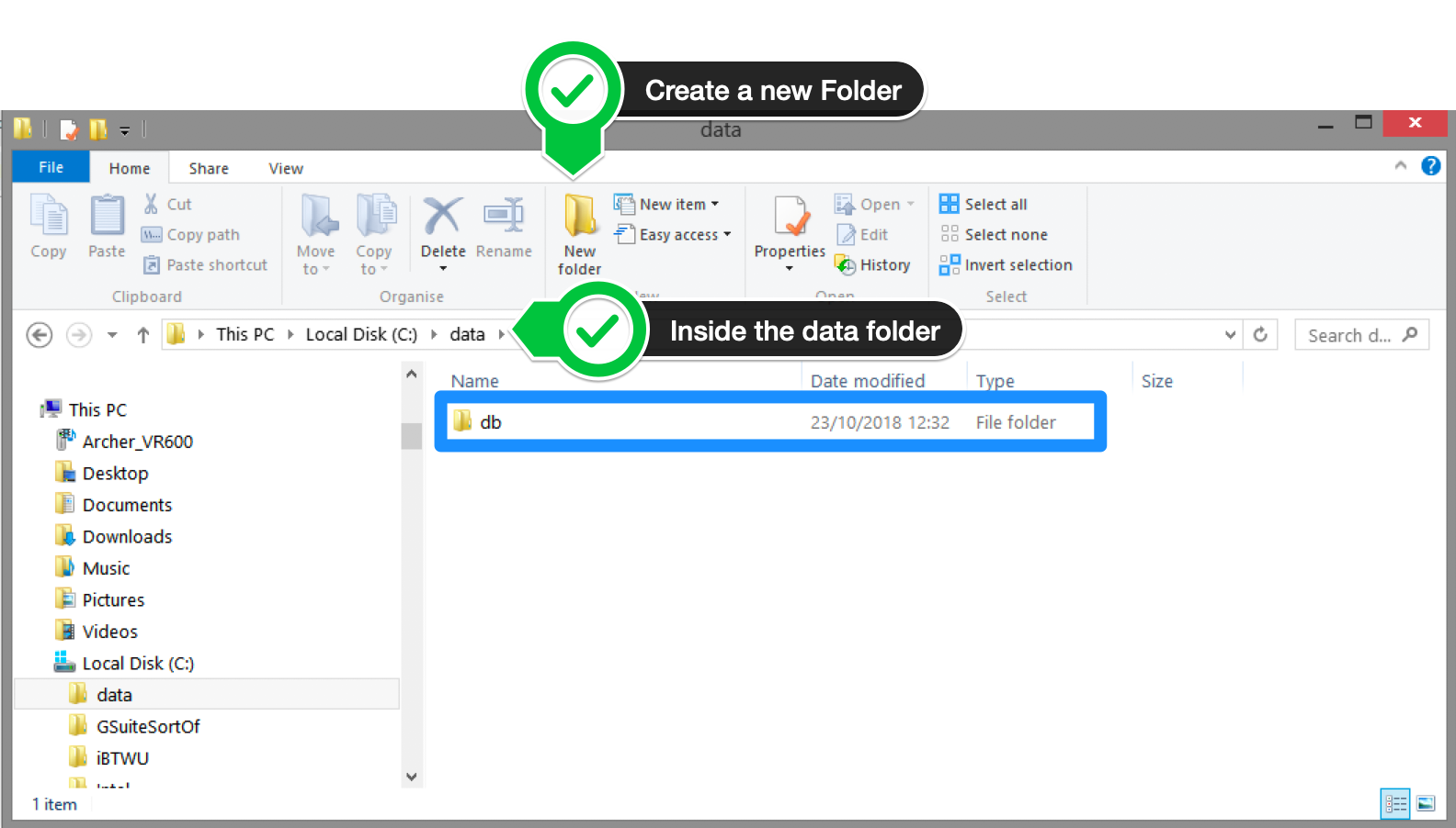

**Step 4 — Setup Alias Shortcuts for Mongo and Mongod**

Once installation is complete, we’ll need to set up MongoDB on the local system.

A. Open up your Hyper terminal running Git Bash.

B. Change directory to your home directory with the following command:

cd ~

C. Here, we’re going to create a file called .bash_profile using the following command:

touch .bash_profile

D. Open the newly created .bash_profile with vim using the following command:

vim .bash_profile

E. In vim, hit the **I** key on the keyboard to enter insert mode.

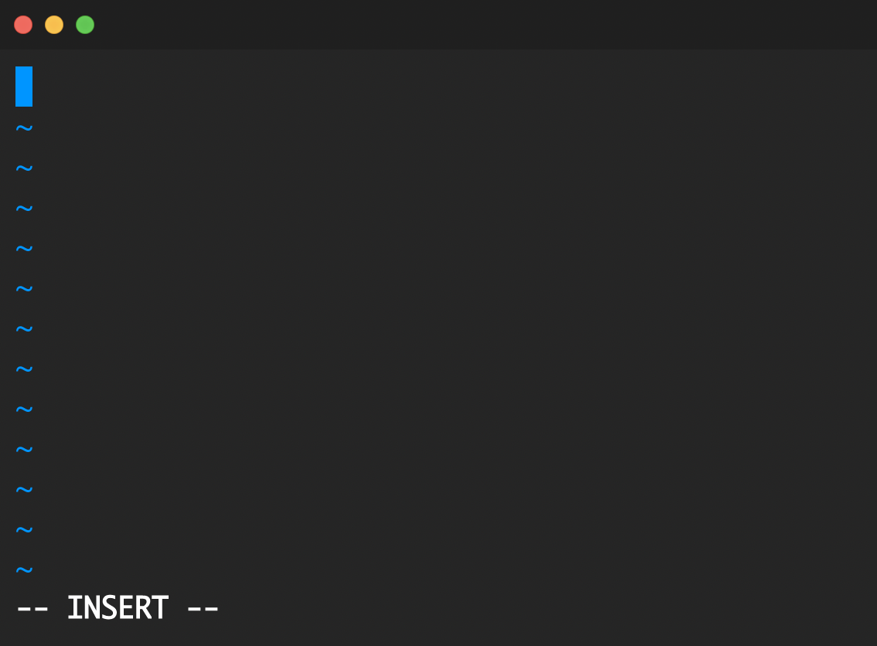

F. In your explorer go to C → Program Files → MongoDB → Server

Now you should see the version of your MongoDB.



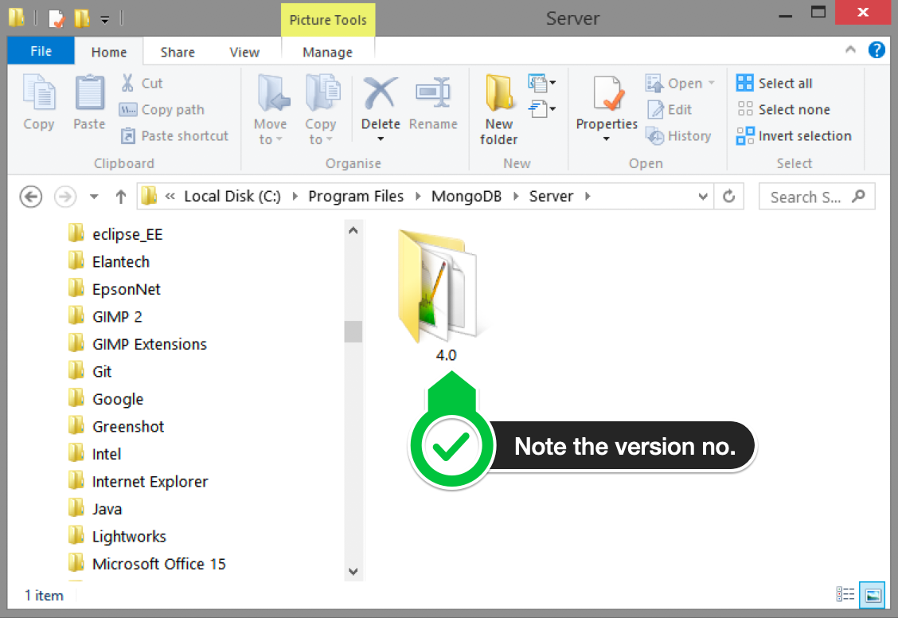

G. Paste in the following code into vim, make sure your replace the 4.0 with your version that you see in explorer

alias mongod="/c/Program\ files/MongoDB/Server/4.0/bin/mongod.exe"  
alias mongo="/c/Program\ Files/MongoDB/Server/4.0/bin/mongo.exe"

F. Hit the Escape key on your keyboard to exit the insert mode. Then type

:wq!

to save and exit Vim.



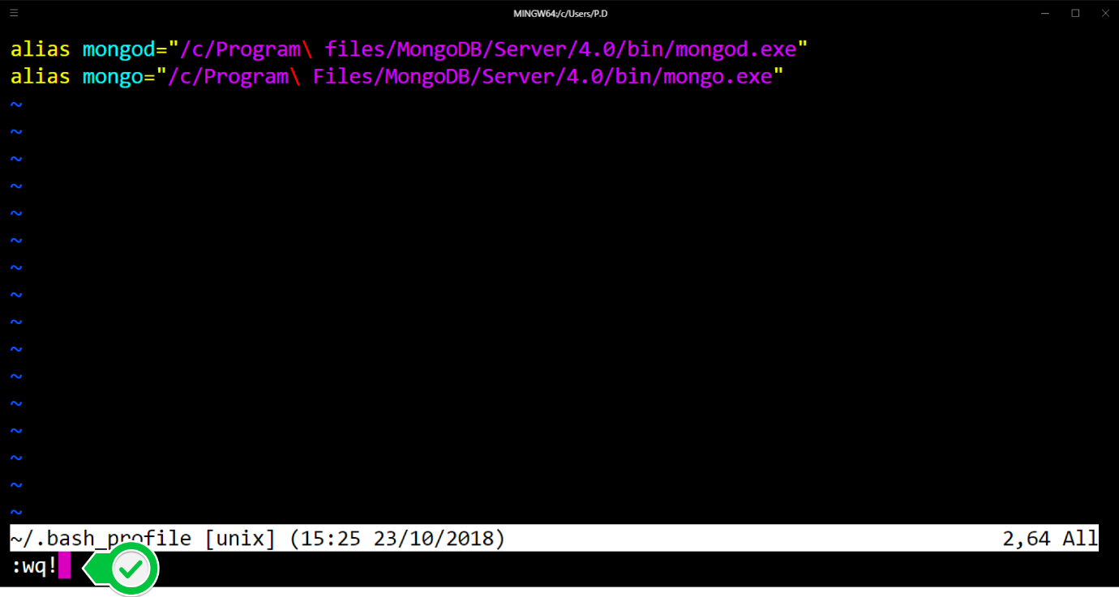

**Step 5 — Verify That Setup was Successful**

A. Close down the current Hyper terminal and quit the application.

B. Re-launch Hyper.

C. Type the following commands into the Hyper terminal:

mongo --version

Once you’ve hit enter, you should see something like this:



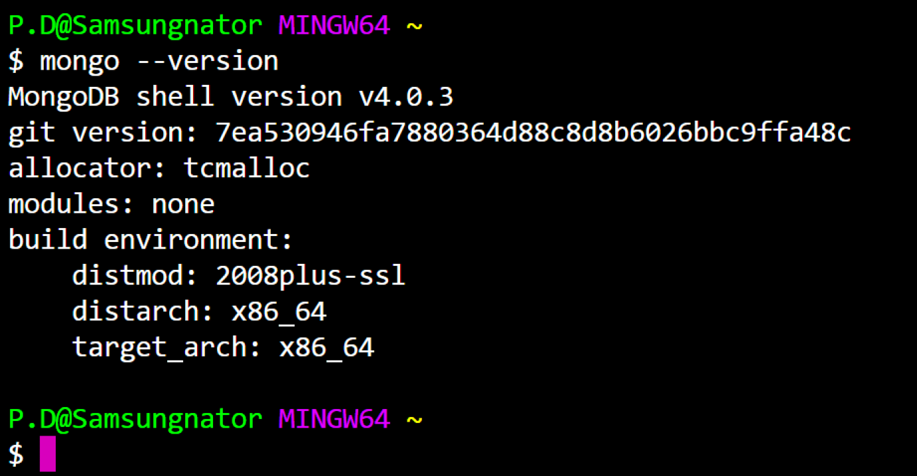

This means that you have successfully installed and setup MongoDB on your local system!

If you see something that looks like bash mongo command not found, then make sure you check back at all the steps above and follow it step-by-step making sure there are no typos and you haven’t missed any of the steps.

**NODE JS**

**How to install?**

**(Download Link provided below)**

<https://nodejs.org/en/download/>

**Step 1)** Go to the site <https://nodejs.org/en/download/> and download the necessary binary files. In our example, we are going to download the 32-bit setup files for Node.js.

[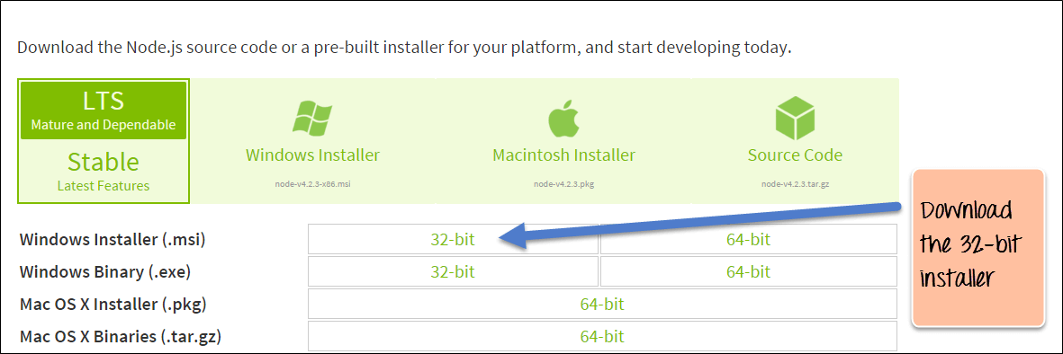](https://www.guru99.com/images/NodeJS/010716_0458_DownloadIns1.png)

**Step 2)** Double click on the downloaded .msi file to start the installation. Click the Run button on the first screen to begin the installation.

[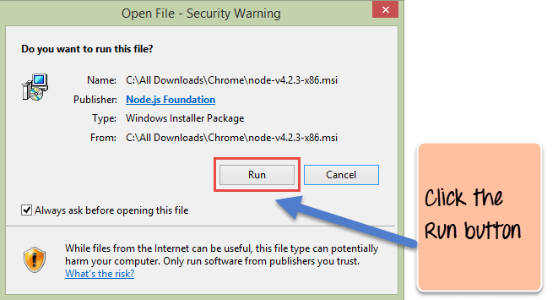](https://www.guru99.com/images/NodeJS/010716_0458_DownloadIns2.png)

**Step 3)** In the next screen, click the "Next" button to continue with the installation

[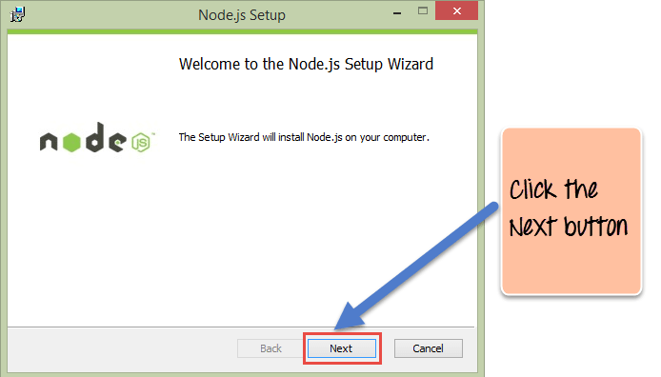](https://www.guru99.com/images/NodeJS/010716_0458_DownloadIns3.png)

**Step 4)** In the next screen, Accept the license agreement and click on the Next button.

[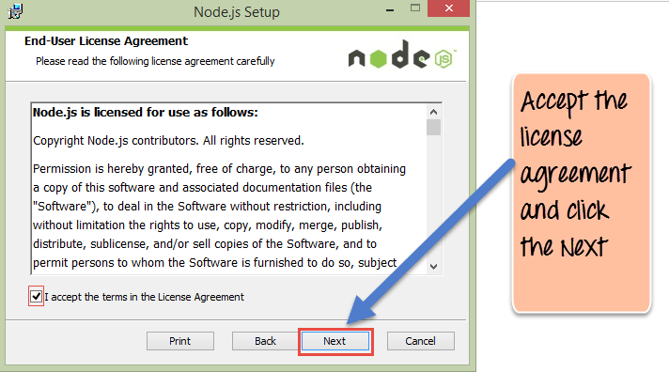](https://www.guru99.com/images/NodeJS/010716_0458_DownloadIns4.png)

**Step 5)** In the next screen, choose the location where Node.js needs to be installed and then click on the Next button.

1. First, enter the file location for the installation of Node.js. This is where the files for Node.js will be stored after the installation.

2. Click on the Next button to proceed ahead with the installation.

[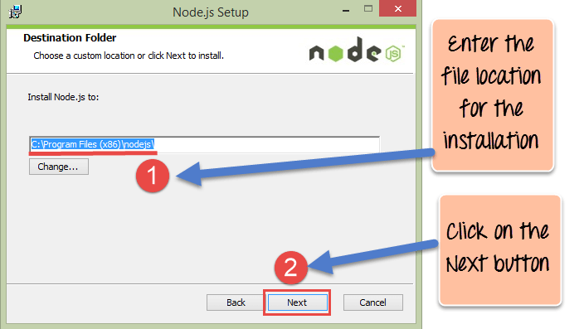](https://www.guru99.com/images/NodeJS/010716_0458_DownloadIns5.png)

**Step 6)** Accept the default components and click on the Next button.

[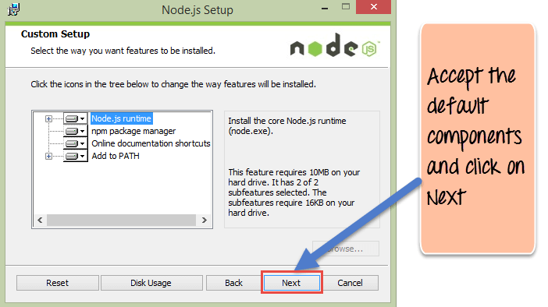](https://www.guru99.com/images/NodeJS/010716_0458_DownloadIns6.png)

**Step 7)**In the next screen, click the Install button to start the installation.

[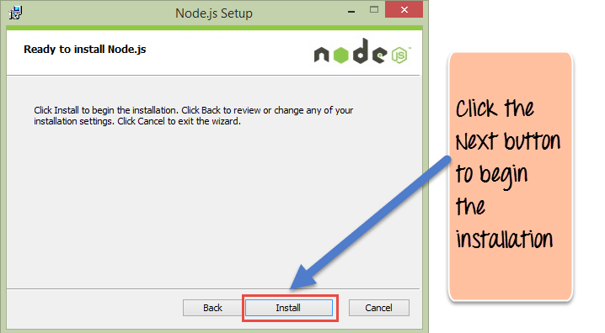](https://www.guru99.com/images/NodeJS/010716_0458_DownloadIns7.png)

**Step 8)** Click the Finish button to complete the installation.

[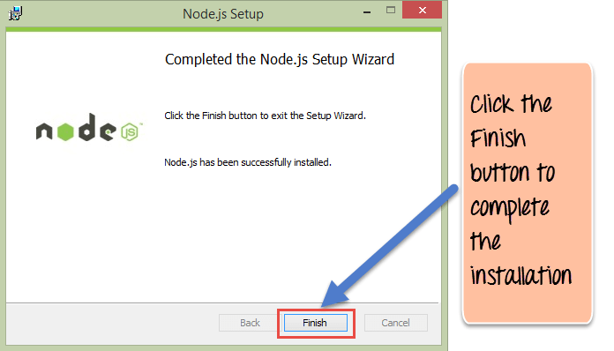](https://www.guru99.com/images/NodeJS/010716_0458_DownloadIns8.png)

Windows is now recommending that developers use Node.js with [WSL2](https://docs.microsoft.com/en-us/windows/nodejs/setup-on-wsl2)(the Windows subsystem for Linux)

**ANGULAR**

VS Code Installation:

Download Link

<https://code.visualstudio.com/download>

Angular Cli Installation:

Command Prompt : *npm install -g @angular/cli*

**EXPRESS JS**

**How to access in Node?**

Command Prompt :  *npm install express --save*